**CATS Time Tracker User Guide**

Contents

About Tool 2

Features 2

Initialization and Adding Chargelines 2

Adding Chargelines 3

Recording Time 3

Exporting Time to SAP 4

# About Tool

The CATS Time Tracker is a desktop application developed with Python and Tkinter, designed to help professionals and teams track their activities and time spent efficiently. This application offers a user-friendly interface to log activities, monitor time investment, and manage tasks with ease.

## Features

* Dynamic Activity Rows: Users can dynamically add activities they're working on and track the time spent on each activity.
* Total Time Tracking: The application calculates and displays the total time spent on all activities throughout the day.
* Activity Charge Lines: Integrates with external data sources to load predefined lists of activities or charge lines for easy selection.
* Data Export: Features an option to export the tracked time data for further processing or integration into systems like SAP.

# Initialization and Adding Chargelines

The first time the program is initialized, a folder structure is created. This folder structure will be created in your documents **\Documents\SAP Time Tracker.**

The contents of the SAP Time Tracker Folder will be:

* Time Records Folder: This Folder will be the location where records of the time tracking for a particular day will be stored. The files are saved in this format **time_charge_MM_DD_YY**

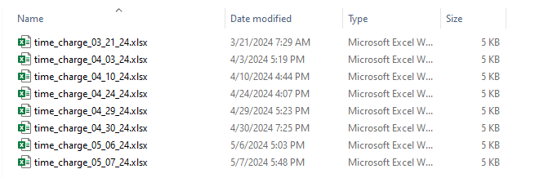

* Chargeline File: This file will contatin all chargelines that will be displayed for timekeeping

## Adding Chargelines

To add a Chargeline, open the Chargeline file, and input the description as well as the relevant network charge numbers as shown below:

Make sure your Network has a valid Operation and Sub-O values. These are the values needed to store the Time on SAP

# Recording Time

After the initial setup and once you've added chargelines to the chargeline document, the tool will automatically fetch this data and present it in a dropdown menu for easy access. Here’s how to start recording time:

* Selecting an Activity: Open the dropdown menu and choose the activity you intend to work on. This list is populated based on the chargelines you've added to the document.
* Starting the Timer: Once you've selected your activity, simply click the play icon. This will initiate the timer, and you'll begin recording the time spent on the selected activity.
* Monitoring Time: On the left side of the tool, you’ll find a display showing the total time spent on the current activity as well as the cumulative time elapsed for all activities. This allows you to monitor your productivity and time allocation across various tasks.

If you need to switch activities or start tracking time for a different task, it's important to manage the time recordings accurately:

* Stopping Current Activity: Before switching to a different activity, make sure to stop the timer for the current one. This ensures that the time recorded is accurate and specific to the activity you were engaged in.
* Recording a New Activity: After stopping the timer, you can select a new activity from the dropdown menu and press the play icon to start recording time for the new task.

# Exporting Time to SAP

Ensuring accurate data transfer is crucial for maintaining the integrity of your records. Follow these steps to upload your activities correctly:

* Stopping Active Time Tracking:

Before proceeding with the upload, it's important to halt any active time tracking. This ensures that all time data is finalized and ready for transfer. Simply stop any running timers associated with your activities.

* Verifying Activity Data:

Check the activities listed in your Excel file to ensure that each one has the correct chargelines associated with it. This step is critical to ensure that the activities align correctly with the financial records in SAP.

* Exporting to SAP:

Once you have verified that all data is correct and all timers are stopped, click the "Export to SAP" button. This action will initiate the transfer of your time tracking data from the Excel file into the SAP system.

* Storing the Record:

Once your time data is in SAP, you have the option to store a record of this data. This will be saved in the Time Records folder.